CALL TO ORDER
ITEMS TO BE WITHDRAWN

APPROVAL OF MINUTES
Regular Meeting – October 16th, 2025

REPORTS
Abatements

PUBLIC HEARINGS
The Commission may conduct a public hearing to inquire into the progress, and circumstances, determine the property owner’s intent, and assess, increase, or decrease civil penalties on or order other abatement methods including, without limitation, demolition of structure upon the property located as follows:

1703 1st St
1301 17th St #E

ADJOURNMENT

CERTIFICATION
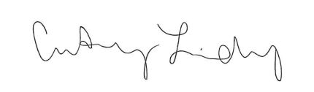
I certify that the above notice of meeting was posted on the bulletin board in City Hall, 501 Center Avenue, Brownwood, Texas on the 12th day of February 2026. I further certify that the following News Media were properly notified of this meeting as stated above: Brownwood Bulletin, Brownwood News, Radio Station KBWD\KOXE, and Radio Station KXYL.

____________________
Courtney Lindsey
Administrative Assistant

SPECIAL ACCOMMODATIONS
People with disabilities who plan to attend this meeting and who may need auxiliary aids or services are requested to contact Christi Wynn at (325) 646-5775 at least twenty-four (24) hours before this meeting so that appropriate arrangements can be made.

