BUILDING AND STANDARDS COMMISSION
PUBLIC NOTICE

Notice is hereby given of the City of Brownwood Building and Standards Commission Hearing to be conducted on Thursday, February 19th, 2026, at 4 pm in the Council Chambers at 501 Center Avenue to inquire into the circumstances, determine the property owner’s intent and to assess, increase or decrease civil penalties or order other abatement methods including, without limitation, demolition of structure upon property located as follows:

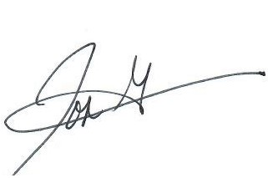
1711 Brady Ave
1301 17th St #D

__________________________
Jose Gonzalez – Code Compliance Official II
Planning & Development Services

CERTIFICATE
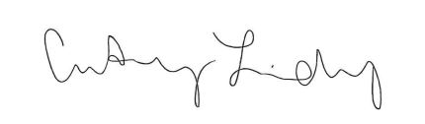
I certify that the above notice of the meeting was posted on the bulletin board in City Hall, 501 Center Avenue Brownwood, Texas on the 29th of January, 2026. I further certify that the following News Media were properly notified of this meeting as stated above: Brownwood Bulletin, Brownwood News, Radio Station KBWD\KOXE, and Radio Station KXYL.

_____________________________
Courtney Lindsey
Planning & Development Services
Administrative Assistant

SPECIAL ACCOMMODATIONS
Persons with disabilities who plan to attend this meeting and who may need auxiliary aide or services are requested to contact Christi Wynn at (325) 646-5775 at least twenty-four (24) hours before this meeting so that appropriate arrangements can be made.

