Planning & Zoning Agenda
Regular Meeting
4:00 p.m., Thursday, February 5th, 2026
Council Chambers, City Hall
501 Center Avenue, Brownwood, Texas

The P&Z Commission may deliberate and/or act on the following items:
Call to Order
Items to be Withdrawn
Approval of Minutes
A. Regular Called Meeting — September 18th, 2025
Ordinance Amendment

- Consider approval of the Final Plat of, replat of Cleveland Addition, BCAD # 51426, being a final plat of 1.30 Acres, located at the Northeast corner of Avenue D & Durham Avenue, for the purpose to subdivide property.
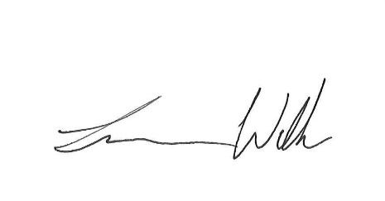

Adjournment Submitted by:

Lance Wells
Planning & Zoning Secretary

Certification
I certify that the above notice of the meeting was posted on the bulletin board in City Hall, 501 Center Avenue, Brownwood, Texas, on January 30, 2026. I further certify that the following news media were properly notified of this meeting as stated above: Brownwood News, Radio Station KBWD/KOXE and Radio Station KXYL.
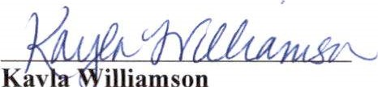

Administrative Assistant

Special Accommodations
This facility is wheelchair accessible and accessible parking spaces are available. Requests for accommodation or interpretive services must be made twenty-four (24) hours prior to this meeting. Please contact Christi Wynn at (325) 646-5775 for further information.

